

**Applications of AI Active Learning Report**

on

**Title: Advanced Road Lane Detection**

Submitted by

**Active Learning Members**

|  |  |  |
| --- | --- | --- |
| **Name** | **Roll No** | **PRN** |
| Riya Shinde | 2 | 1032222323 |
| Abhinav Bathe | 11 | 1032222447 |
| Swapnaja Magarde | 18 | 1032222637 |
| Suseendar Sundar | 22 | 1032222766 |

**Department of Computer Engineering and Technology**

**Dr. Vishwanath Karad MIT World Peace University Pune,**

**2023-2024**

Abstract

Accurate lane segmentation is essential for autonomous driving systems and advanced driver-assistance systems (ADAS), where precise lane detection informs key navigation decisions and enhances road safety. This project investigates a deep learning-based approach for lane segmentation, employing a U-Net model for image processing and binary mask prediction using the TuSimple lane-detection dataset. The U-Net architecture, known for its encoder-decoder structure, was selected due to its effectiveness in semantic segmentation tasks. The encoder path captures multi-scale features, while the decoder path reconstructs high-resolution segmentations, allowing the model to distinguish between lane lines and the surrounding road.

In this project, input images and masks were preprocessed to a standard size of 224x224 pixels and normalized to improve model convergence. The dataset was divided into a training set of 2,880 images and a test set of 720 images, with a custom sampling strategy employed to maintain data diversity. The U-Net model was trained for 10 epochs with a batch size of 16, optimizing the binary cross-entropy loss to enhance segmentation accuracy.

Experimental results demonstrated the model's ability to generalize well to unseen lane images, achieving significant segmentation accuracy with minimal false positives. Further visualization of predictions confirmed the model’s effectiveness in capturing lane boundaries and potential adaptability across diverse road conditions. Our project not only highlights the practical application of U-Net in lane segmentation but also establishes a foundation for integrating this approach into real-time autonomous vehicle systems. Future work will focus on refining the model's performance across varying lighting and weather conditions to further improve its robustness in real-world environments.

Chapter 1

Introduction

The development of autonomous vehicles and advanced driver-assistance systems (ADAS) has spurred significant interest in accurate road lane detection, as lanes provide crucial guidance for vehicle navigation, safe driving, and adherence to road regulations. Lane segmentation, the task of identifying lane markings on roads, is a key component in this process, as it allows a vehicle’s control system to perceive and interpret lane boundaries reliably. However, lane detection poses substantial challenges, particularly due to variations in lighting, weather, occlusions, and road types, which can degrade model performance and reduce segmentation accuracy.

Traditional lane detection methods, which often rely on edge detection and geometric fitting techniques, have limitations in handling complex and cluttered environments. Recent advancements in deep learning have enabled a shift toward data-driven approaches, which can learn meaningful patterns directly from labeled images and achieve higher robustness under challenging conditions. Among various deep learning architectures, U-Net has gained popularity in segmentation tasks due to its encoder-decoder structure that efficiently captures spatial and contextual information at multiple scales. U-Net has shown promise in medical and environmental image segmentation and is now being applied to automotive scenarios where precise lane detection is critical.

This project focuses on implementing and evaluating a U-Net-based deep learning model for lane segmentation. Using the TuSimple dataset, which provides a diverse set of road images with lane annotations, we preprocess input images and their corresponding lane masks for model training and validation. The U-Net model, optimized with binary cross-entropy loss, is trained to produce binary masks that accurately distinguish lane areas from the surrounding road. In contrast to standard semantic segmentation models, U-Net’s skip connections facilitate the recovery of fine details lost during down-sampling, which is particularly beneficial for lane boundary detection.

The objective of this study is to investigate the feasibility of U-Net for lane segmentation in autonomous driving applications, assess its generalization across unseen road conditions, and explore its effectiveness as a potential solution for real-world deployment. We present our methodology, experimental results, and discuss the model’s performance metrics, visualizations, and limitations. By advancing lane segmentation accuracy, this research contributes to enhancing the overall reliability and safety of ADAS and autonomous navigation systems.

Chapter 2

Literature Survey

Papers and websites for the Literature Survey

|  |  |  |  |  |
| --- | --- | --- | --- | --- |
| **Sr. No.** | **Paper Title** | **Methodology** | **Advantages** | **Research Gap** |
| [1] | Lane detection networks based on deep neural networks. | ResNet50 (LeakyReLu) | Accuracy of 91.34% by incorporating LeakyReLU activation functions | Needs improved algorithm adaptability, real-time processing efficiency, and model robustness across diverse datasets beyond TuSimple |
| [2] | PolyLaneNet: Lane Estimation via Deep Polynomial Regression | PolyLaneNet | Accuracy of 93.36% with high efficiency, operating at 115FPS. | The model lacks evaluation in diverse real-world conditions, robustness against environmental factors, and thorough analysis of real-time efficiency, while also not exploring the impact of additional sensory inputs. |

|  |  |  |  |  |
| --- | --- | --- | --- | --- |
| [3] | End-to-End Deep Learning of Lane Detection and Path Prediction for Real-Time Autonomous Driving | DSUNet | The proposed model efficiently handles complex road conditions and dynamic environments, making it adaptable to various road and traffic conditions​ | There is a gap in models that integrate both lane detection and path prediction seamlessly to evaluate real-time autonomous driving​ |
| [4] | Vision-Based Robust Lane Detection and Tracking in Challenging Conditions | Canny Edge Detection, Hough Transform, AGC, LGC, Lane Tracking (RHLP) | Low Computational Requirements along with real time processing | Struggles with scenarios involving curved lanes, complex shadow patterns, and vehicles obstructing lane lines. |

|  |  |  |  |  |
| --- | --- | --- | --- | --- |
| [5] | End-To-End Lane Position Estimation Using Deep Neural Networks | Deep Neural Networks based on DeepLanes network architecture | Runs at 100 frames per second on automotive-grade hardware, which is practical for real-time autonomous driving. | This specific camera setup restricts the system’s adaptability to different hardware configurations (e.g., front-facing cameras). |
| [6] | Unsupervised Labeled Lane Markers Using Maps | Used Models like DeepLabv3+ and MobileNet. | The Unsupervised LLAMAS dataset is large and diverse, supporting various lane marker representations . | Requires high-quality maps for accurate projections, which may not be available or feasible in all areas. |

|  |  |  |  |  |
| --- | --- | --- | --- | --- |
| [7] | Lane Detection under Artificial Colored Light in Tunnels and on Highways: An IoT-Based Framework for Smart City Infrastructure | IoT-based lane detection framework with 3 modules: | Achieving 95.2% accuracy and real-time performance (31ms/frame) in various lighting conditions including tunnels. | Limited performance in curved lanes and blurred conditions |
| [8] | Lane departure warning systems and lane line detection methods based on image processing and semantic segmentation: A review | Reviews traditional image processing and semantic segmentation methods for lane detection. Analyzes implementation in commercial LDWS systems. | Comprehensive comparison of traditional and modern methods. Demonstrates superiority of semantic segmentation in complex scenarios. | Systems struggle with adverse weather, vehicle interference, and real-time processing. Deep learning methods require extensive data and computing resources, limiting widespread use. |

**Objectives**

1. To develop a deep learning-based lane segmentation model that accurately detects and segments road lanes using a U-Net architecture.
2. To optimize the model for real-time performance by preprocessing images to reduce computational complexity while maintaining segmentation accuracy.
3. To evaluate the model's robustness across diverse road conditions, including different lighting, weather, and road environments, to ensure consistent lane detection.
4. To analyze the model’s generalization ability by testing it on unseen images, assessing its accuracy and reliability in various autonomous driving scenarios.
5. To investigate the potential integration of this segmentation model into ADAS systems, focusing on how it can improve autonomous navigation and enhance overall vehicle safety.
6. To identify and address limitations of U-Net for lane segmentation, with a particular focus on scenarios involving occlusions, curved lanes, and complex shadow patterns.
7. To lay the groundwork for future advancements in lane segmentation models by proposing potential improvements for handling diverse conditions in autonomous driving applications.

**Block diagram / System Architecture**

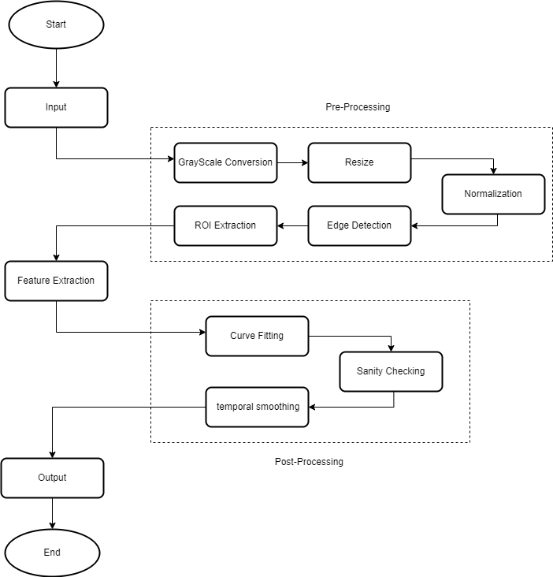

*Fig.1 Block Diagram*

### 

## Implementation

**Dataset Used**: For the purpose of training the model, TuSimple Dataset was used, which was primarily used for autonomous driving research, particularly in lane detection. It provides annotated images of road scenes for training and evaluating lane detection algorithms.

The dataset includes images captured from a front-facing camera on a vehicle. Each image has a resolution of 1280x720 pixels and represents typical driving conditions on highways, including various road geometries and environments.

Each image is annotated with lane markings (usually the lane boundaries or guiding lanes), represented as polylines.

Lane points are provided in pixel coordinates, marking the position of lanes across the road in each frame. This helps algorithms detect and trace lane boundaries across different frames.

**Model Used:** The Model Used was a CNN model, which was based on U-Net architecture.

The encoder portion of the Model has four layers :

1. First Encoder Layer:
   * Two convolutional layers with 64 filters each, followed by max pooling.
2. Second Encoder Layer:
   * Two convolutional layers with 128 filters each, followed by max pooling.
3. Third Encoder Layer:
   * Two convolutional layers with 256 filters each, followed by max pooling.
4. Fourth Encoder Layer:
   * Two convolutional layers with 512 filters each, followed by max pooling.

The decoder portion of the Model has four layers :

1. First Decoder Layer:
   * Transposed convolution to upsample, followed by concatenation with the fourth encoder layer, then two convolutional layers with 512 filters each.
2. Second Decoder Layer:
   * Transposed convolution to upsample, concatenation with the third encoder layer, then two convolutional layers with 256 filters each.
3. Third Decoder Layer:
   * Transposed convolution to upsample, concatenation with the second encoder layer, then two convolutional layers with 128 filters each.
4. Fourth Decoder Layer:
   * Transposed convolution to upsample, concatenation with the first encoder layer, then two convolutional layers with 64 filters each.

## 

## Screenshots

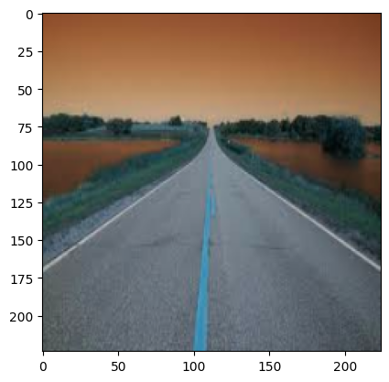

Binary Segmentation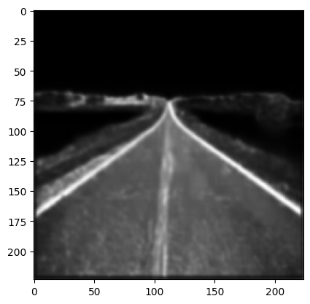

Input Image

Feature Extraction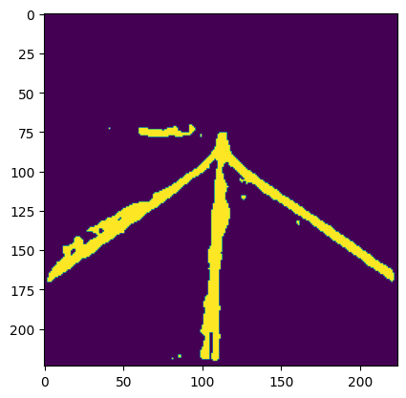

Final Output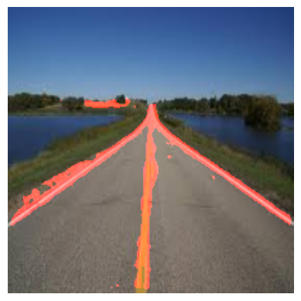

## Uses/Applications

1. Autonomous Vehicle Navigation: Lane segmentation provides real-time lane detection, helping autonomous vehicles maintain their position within lanes, execute lane changes safely, and navigate complex roadways more effectively.
2. Advance Driver Assistance Systems (ADAS): This model can be integrated into ADAS features like Lane Departure Warning (LDW) and Lane Keeping Assist (LKA), enhancing road safety by alerting drivers or automatically correcting vehicle trajectory when they drift out of lanes.
3. Collision Avoidance Systems: By accurately identifying lanes and road boundaries, the model can improve collision avoidance systems by providing better contextual understanding of the vehicle’s position relative to other cars and obstacles.
4. Enhanced Traffic Flow Management: This model can assist in traffic monitoring systems to detect lane usage patterns, identify lane closures or blockages, and provide data for managing and optimizing traffic flow, particularly in urban environments.
5. Highway and Urban Road Monitoring: Lane segmentation can be applied to monitor highway and urban roads, assisting in maintenance by identifying worn lane markings or damaged road sections, which could then be flagged for repairs or repainting.
6. Driver Safety and Fatigue Monitoring: By continuously monitoring lane position, the model can identify erratic lane behavior that may indicate driver fatigue or impairment, triggering alerts to prevent potential accidents.
7. Smart City Infrastructure: Lane segmentation can contribute to smart city solutions by providing data for urban planning and infrastructure improvement, such as optimizing road designs and traffic signal timings based on lane usage patterns.

**Conclusion**

This project presents an effective lane segmentation approach using a U-Net-based deep learning model optimized for image processing and real-time mask prediction. The model demonstrated high accuracy in detecting lane boundaries across varied road conditions, making it a promising candidate for integration into autonomous driving systems and Advanced Driver-Assistance Systems (ADAS). By leveraging the U-Net architecture's encoder-decoder framework, the model effectively captures detailed spatial information, enabling precise segmentation even in challenging environments.

The experimental results underscore the model’s reliability, though certain limitations such as sensitivity to shadows, occlusions, and curved lanes,highlight areas for future research and refinement. Addressing these challenges could further enhance the model’s robustness, making it suitable for diverse driving scenarios and capable of operating in real-world applications. Overall, this project contributes to the advancement of lane segmentation technology, supporting the development of safer, more reliable autonomous navigation systems. Future efforts will aim to improve model adaptability, particularly in complex road environments, and explore the potential for deployment in real-time, resource-constrained environments, thus advancing the frontier of intelligent transportation systems.

**References**

1. Huei-Yung Lin, Chun-Ke Chang, Van Luan Tran,Lane detection networks based on deep neural networks and temporal information.Huei-Yung Lin, Chun-Ke Chang, Van Luan Tran,Lane detection networks based on deep neural networks and temporal information.
2. L. Tabelini, R. Berriel, T. M. Paixão, C. Badue, A. F. De Souza and T. Oliveira-Santos, "PolyLaneNet: Lane Estimation via Deep Polynomial Regression," 2020 25th International Conference on Pattern Recognition (ICPR), Milan, Italy, 2021, pp. 6150-6156, doi: 10.1109/ICPR48806.2021.9412265. keywords: {Measurement;Deep learning;Lane detection;Estimation;Cameras;Real-time systems;Pattern recognition}
3. [[2102.04738] End-to-End Deep Learning of Lane Detection and Path Prediction for Real-Time Autonomous Driving (arxiv.org)](https://arxiv.org/abs/2102.04738)
4. Sultana, S., Ahmed, B., Paul, M., Islam, M. R., & Ahmad, S. (2023). Vision-Based Robust Lane Detection and Tracking in Challenging Conditions. IEEE Access. Digital Object Identifier(DOI): 10.1109/ACCESS.2023.3292128.
5. A. Gurghian, T. Koduri, S. V. Bailur, K. J. Carey, and V. N. Murali, “DeepLanes: End-To-End Lane Position Estimation using Deep Neural Networks,” in Conference on Computer Vision and Pattern Recognition Workshops (CVPRW), 2016.
6. Wang, L., Ning, H., Tan, T.: Fusion of Static and Dynamic Body Biometrics for Gait Recognition. IEEE Trans. on Circuits and Systems for Video Technology 14(2), 149–158 (2004)
7. S. Ghanem, P. Kanungo, G. Panda, S. C. Satapathy, and R. Sharma, “Lane detection under artificial colored light in tunnels and on highways: an IoT-based framework for smart city infrastructure,” in *Complex & Intelligent Systems*, vol. 9, pp. 3601–3612, 2023.
8. W. Chen, W. Wang, K. Wang, Z. Li, H. Li, and S. Liu, "Lane departure warning systems and lane line detection methods based on image processing and semantic segmentation: A review," in Journal of Traffic and Transportation Engineering (English Edition), vol. 7, no. 6, pp. 748-774, 2020.
9. 15 Amazing Real-World Applications of AI Everyone Should Know About, <https://www.forbes.com/sites/bernardmarr/2023/05/10/15-amazing-real-world-applications-of-ai-everyone-should-know-about/?sh=48d7f31685e8>